WRITING IN BINARY

Convert the following numbers to binary using the charts

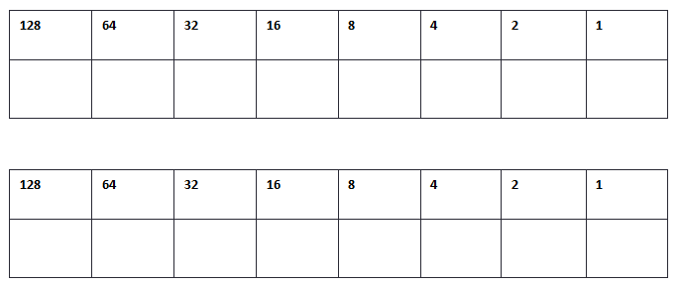
32
34
43
122

Now try writing the binary without the charts

56
____________________________

38
____________________________

121
____________________________

9
____________________________

18
____________________________

